Resources for TEAP Accreditation

Understanding the role of discourse in course design & teaching

AP1: You articulate understanding of a range of characteristics of academic texts, such as rhetorical and discourse features beyond sentence level.

AP4: You incorporate knowledge of textual features and processing strategies into lesson planning.

FT4: You adapt teaching or learning material for specific academic contexts or disciplines.

FT10: You raise awareness of discourse features in your teaching

FT11: You train students to investigate practices of a discipline.

Recent experience of assessing TEAP portfolios has highlighted discourse as an area where applicants can struggle to understand the criteria or provide sufficient evidence of the theoretical underpinnings of their practice.

There are a number of competing theories of discourse and it can be confusing to understand how each applies in practice. The most comprehensive theory, which describes how the structure of English relates to the situational variables of a social context (e.g. business, engineering, education) in which language is being used is Systemic Functional Linguistics (SFL). This theory of language aims to understand how users of a language choose what to say or write depending on the cultural context in which they want to communicate. There is a two-way relationship between context and language so that choices in one impact on what it is possible to choose in the other.[1]

The materials below are adapted from a course in academic grammar for students of science and engineering (the context). The aim was to use simple easily-understood texts to demonstrate aspects of SFL theory in practice, following the pedagogical model in Alexander *et al*. (2018)[2]

These materials use the introduction to an early experiment reported by Isaac Newton to illustrate a framework set out in Writing Science by Halliday and Martin (1991).[3] The time of writing 1671 determined the language choices in Newton’s introduction but new developments in science led to changes in the grammatical structures used to report these.

Writing up research – the context informs the genre and language

The way that scientific papers are written has changed considerably since Newton first wrote his letter for publication in Philosophical Transactions of the Royal Society, No. 80 (19 Feb. 1671/2), pp. 3075-3087. At the time of writing, Newton was one of a small number of natural philosophers (i.e. scientists) who knew each other well and usually corresponded by letter to tell each other of their scientific discoveries. Founding editor, Henry Oldenberg, started *Philosophical Transactions* in 1665 as a way of reducing the number of letters he wrote to individual correspondents. Authors initially continued to use the letter format they were used to.

Writing up research – analysing language choices

SIR: To perform my late promise to you, I shall without further ceremony acquaint you, that in the beginning of the Year1666 I procured me a Triangular glass Prisme, to try therewith the celebrated Phænomena of Colours. And in order thereto having darkened my chamber, and made a small hole in my window-shuts, to let in a convenient quantity of the Suns light, I placed my Prisme at his entrance, that it might be thereby refracted to the opposite wall. It was at first a very pleasing divertisement, to view the vivid and intense colours produced thereby; but after a while applying myself to consider them more circumspectly, I became surprised to see them in an oblong form; which, according to the received laws of Refraction, I expected should have been circular.[4]

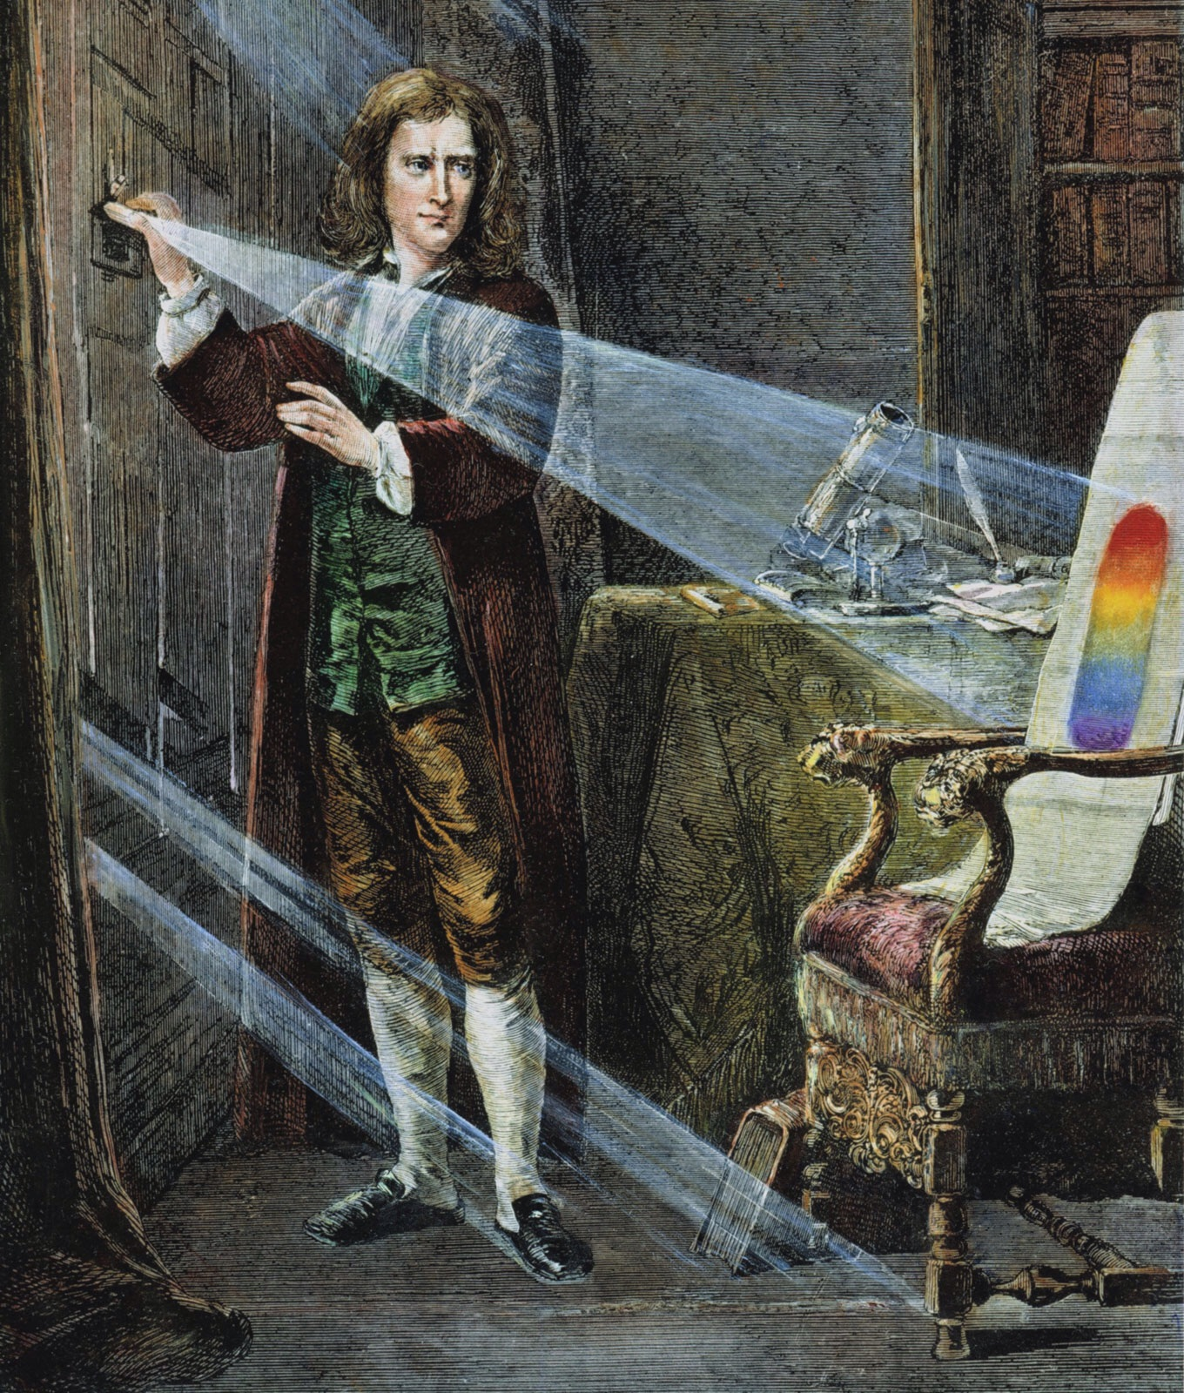

**Task** The style is very personal with Newton using the first person ‘*I’* to show himself as the agent carrying out the experiment. Can you identify and find evidence in the text for

* the genre, i.e. what type of text this is, who is the reader and what is the purpose
* the main functions which express the method and results of the experiment
* cohesive devices which link ideas together
* Newton’s evaluation of the results
* Reference to other studies carried out previously
* A problem that needs further investigation

What is the theoretical concept that underlies Newton’s experiment?

Which parts of Newton’s text describe or explain phenomena?

Do any parts of the text attempt to convince the reader to accept a particular interpretation?

Writing up research – the language and genre reflect the context

The phenomenon of a rainbow in the real world can be explained by the concept of dispersion, as Newton showed in his experiment. Drops of rain act as prisms that separate the components of light. Here are three descriptions of rainbows. The language choices in these descriptions reflect the genre (audience and purpose) of each text. How are they different?

1) And forgetting, startled, she looked for the hovering colour and saw a rainbow forming itself. In one place it gleamed fiercely, and, her heart anguished with hope, she sought the shadow of iris where the bow should be. Steadily the colour gathered, mysteriously, from nowhere, it took presence upon itself, there was a faint, vast rainbow. The arc bended and strengthened itself till it arched indomitable, making great architecture of light and colour and the space of heaven, its pedestals luminous in the corruption of new houses on the low hill, its arch the top of heaven.[5]

2) Rainbow

From Wikipedia the free encyclopedia[6]

A **rainbow** is a [meteorological](http://en.wikipedia.org/wiki/Meteorology) phenomenon that causes a [spectrum](http://en.wikipedia.org/wiki/Optical_spectrum) of [light](http://en.wikipedia.org/wiki/Light) to appear in the sky when the Sun shines on to droplets of moisture in the [Earth's atmosphere](http://en.wikipedia.org/wiki/Earth%27s_atmosphere). It takes the form of a [multicoloured](http://en.wikipedia.org/wiki/Color) [arc](http://en.wikipedia.org/wiki/Arc_%28geometry%29), with red on the outer part of the arc and violet on the inner section. A rainbow spans a continuous spectrum of colours; the distinct bands are an artefact of human [colour vision](http://en.wikipedia.org/wiki/Color_vision). The most commonly cited and remembered sequence, in English, is [Newton's](http://en.wikipedia.org/wiki/Isaac_Newton) sevenfold red, orange, yellow, green, blue, [indigo](http://en.wikipedia.org/wiki/Indigo) and violet. Rainbows can be caused by other forms of water than rain, including mist, spray, and [dew](http://en.wikipedia.org/wiki/Dew).

## 3) Spectacular Spectrums: 10 Amazing Rainbows [7]

By Steve in 7 Wonders Series, Nature & Ecosystems, Science & Research

Gloriously hued and ephemeral in nature, rainbows are one of the most beautiful sights the skies have to offer. They come in a wide variety of shapes, styles, sizes and yes, even colors. These ten amazing arcs show what happens when Mother Nature gets out her paintbox.

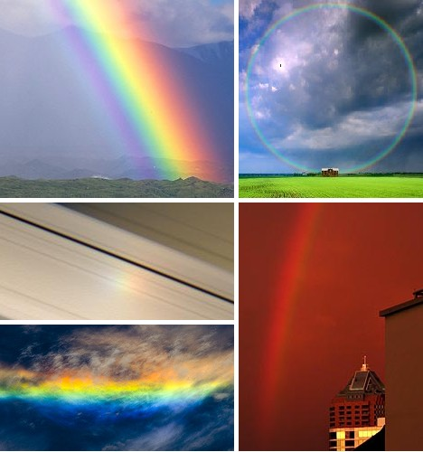

Writing up research – analysing language choices KEY

SIR: To perform my late promise to you, I shall without further ceremony acquaint you, that in the beginning of the Year1666 I procured me a Triangular glass-Prisme, to try therewith the celebrated Phænomena of Colours. And in order thereto having darkened my chamber, and made a small hole in my window-shuts, to let in a convenient quantity of the Suns light, I placed my Prisme at his entrance, so that it might be thereby refracted to the opposite wall. It was at first a very pleasing divertisement, to view the vivid and intense colours produced thereby; but after a while applying myself to consider them more circumspectly, I became surprised to see them in an oblong form; which, according to the received laws of Refraction, I expected should have been circular.

Genre: letter with salutation and personal form of address

Function: process with Newton as the agent in subject position; and purpose to explain why steps in the method were carried out.

Cohesion: archaic linking words

Evaluation: Newton’s personal response to the results

Reference to previous studies: absence of source references as he expects his audience to know these

*Problem*: the results are unexpected and require further study

The theoretical concept underlying this experiment is dispersion of light.

The text describes the process of dispersing light with a prism and begins to explain the unexpected results.

There is no attempt in this part of the text to convince the reader to accept a specific interpretation.

Writing up research – the language and genre reflect the context KEY

The language in texts 1 and 3 evokes an emotional context whereas text 2 is a neutral explanation of the causes of a natural phenomenon. Functional language is highlighted in text 2. Words which have emotional connotations are highlighted in texts 1 and 3. These are mainly adjectives and adverbs.

**RAINBOWS**

1) And forgetting, startled, she looked for the hovering colour and saw a rainbow forming itself. In one place it gleamed fiercely, and, her heart anguished with hope, she sought the shadow of iris where the bow should be. Steadily the colour gathered, mysteriously, from nowhere, it took presence upon itself, there was a faint, vast rainbow. The arc bended and strengthened itself till it arched indomitable, making great architecture of light and colour and the space of heaven, its pedestals luminous in the corruption of new houses on the low hill, its arch the top of heaven.

Describing the rainbow as if it is alive and has agency, actively able to form itself rather than just appearing as a natural phenomenon.

2) A factual description defining rainbows and explaining what causes them to form

Cause and effect describing an object

A **rainbow** is a [meteorological](http://en.wikipedia.org/wiki/Meteorology) phenomenon that causes a [spectrum](http://en.wikipedia.org/wiki/Optical_spectrum) of [light](http://en.wikipedia.org/wiki/Light) to appear in the sky when the Sun shines on to droplets of moisture in the [Earth's atmosphere](http://en.wikipedia.org/wiki/Earth%27s_atmosphere). It takes the form of a [multicoloured](http://en.wikipedia.org/wiki/Color) [arc](http://en.wikipedia.org/wiki/Arc_%28geometry%29), with red on the outer part of the arc and violet on the inner section. A rainbow spans a continuous spectrum of colours; the distinct bands are an artefact of human [colour vision](http://en.wikipedia.org/wiki/Color_vision). The most commonly cited and remembered sequence, in English, is [Newton's](http://en.wikipedia.org/wiki/Isaac_Newton) sevenfold red, orange, yellow, green, blue, [indigo](http://en.wikipedia.org/wiki/Indigo) and violet. Rainbows can be caused by other forms of water than rain, including mist, spray, and [dew](http://en.wikipedia.org/wiki/Dew).

## 3) Spectacular Spectrums: 10 Amazing Rainbows



Gloriously hued and ephemeral in nature, rainbows are one of the most beautiful sights the skies have to offer. They come in a wide variety of shapes, styles, sizes and yes, even colors. These ten amazing arcs show what happens when Mother Nature gets out her paintbox.  
Giving agency to Nature as a person to form rainbows.

Explaining language choices through an SFL model

At the time Newton was writing, the language of science was beginning to evolve from clausal structures of the kind illustrated in his introduction – which encoded processes as verbs, participants as nouns and relations between processes as conjunctions – towards nominal structures – which encoded processes as nouns and relations as verbs. These changes can in fact be seen in the body of his report. They enabled scientists to

* label material processes with noun phrases, e.g. the Phænomena of Colours thus creating new scientific terms
* relate them externally to each other, e.g. *shining light through a prism causes the components of light to disperse*
* relate them internally through interpretation, e.g. *dispersion of light through a prism proves that light is made up of different components*[8]

The preferred format for explaining physical phenomena evolved

from *a happens; so x happens*

*happening a causes happening x*

to *happening a is the cause of happening x*

In other words, scientists and researchers now write about relationships between concepts and processes, and not about people and what they do and think.

The important features of academic writing can be summarised as follows:

1. Write about concepts and processes and how they relate together not about people and what they do and think. You need labels, in the form of noun phrases, for the concepts and processes.
2. Tell your reader what you are going to do before you do it.
3. Structure your explanation from general to specific and familiar to new so that you
   1. give the reader the Big Picture before you fill in the details
   2. remind them what they know before you introduce something new.
4. Use summarizing noun phrases, e.g*. this concept, this problem*, to link ideas in preference to signpost expressions.
5. Use functional language for defining, classifying, comparing, contrasting, linking causes and effects, discussing problems and solutions, linking evidence to claims in an argument.

Analysing texts – top-down and bottom-up frameworks[9]

*Genres* are typical texts with names, e.g. research report. Genre analysis answers the questions

* Who are the readers of this text?
* Why was it written? What is it trying to achieve?
* What structure has been selected to achieve the purpose for the audience?
* What are the stages or moves in this structure?

*Functions* show relations between ideas, e.g. comparison, cause, usually at paragraph level; they create cohesion in text through sentence linking devices; function analysis answers the questions

* What is the relationship between ideas in this paragraph?
* How do these ideas link with what was written before?
* What functional language shows this relationship and these links?

*Phrases* and *sentences* are the basic building blocks of texts; they fit inside each other like Russian dolls according to well-established patterns and rules; sentence analysis answers the questions

* What am I talking about?
* What am I saying about it?
* What is the situation in which the activity happens?

*Words* have different connotations, i.e. secondary meanings which evoke ideas or feelings in addition to the primary meaning. These can introduce positive or negative evaluation into texts.

* What feelings does the writer intend to evoke in the reader?

1. Gillett (n.d) <https://www.uefap.com/grammar/intro/sfl-intro.htm>, accessed 20.6.24, gives a clear account of the components of this theory.
2. Alexander, O., Argent, S. and Spencer, J.A., 2nd Edition. (2019) *EAP Essentials: a teacher’s guide to principles and practice*. Reading: Garnet Education. Chapter 2 Text Analysis.
3. Halliday, M.A.K.(1993) On the language of physical science. In Halliday and Martin, *Writing Science*, pp 54-68. London: The Falmer Press.
4. Source <https://en.wikipedia.org/wiki/Philosophical_Transactions_of_the_Royal_Society> 20.6.24

   Available online from <http://www.newtonproject.sussex.ac.uk/view/texts/normalized/NATP00006>. Image available online <http://warehouse-13-artifact-database.wikia.com/wiki/Isaac_Newton's_Prism>
5. The Rainbow by D.H. Lawrence p 300 Digireads.com Available in Google Books.
6. Available from <http://en.wikipedia.org/wiki/Rainbow>. Accessed 20.06.24
7. Available from [http://laughingmotherofallmothers.blogspot.co.uk/2011/04/amazing-rainbows.html Accessed 11.12.16](http://laughingmotherofallmothers.blogspot.co.uk/2011/04/amazing-rainbows.html%20Accessed%2011.12.16). No longer available on this site.
8. Halliday, M.A.K.(1993) On the language of physical science. In Halliday and Martin, *Writing Science*, pp 54-68.
9. Framework taken from Alexander, O., Argent, S. and Spencer, J.A., 2nd Edition. (2019) *EAP Essentials: a teacher’s guide to principles and practice*. Reading: Garnet Education. Chapter 2 Text Analysis.