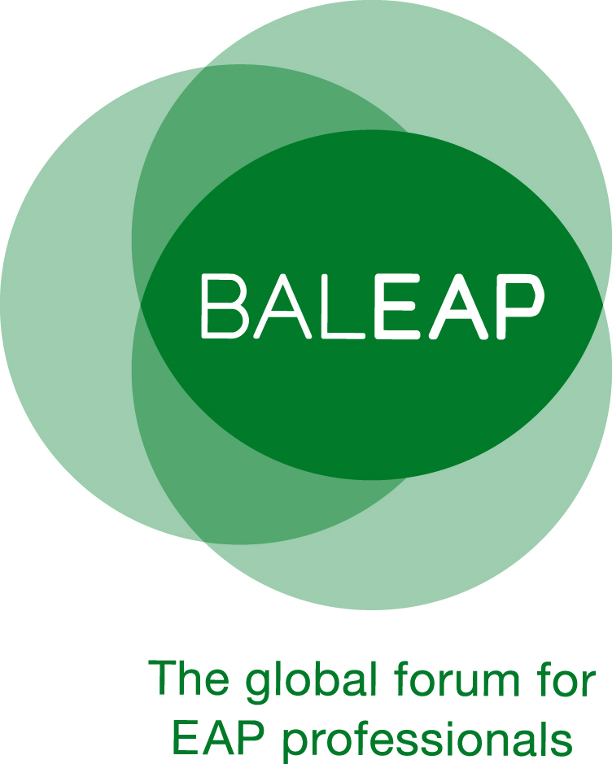 | English for Academic Purposes  2025* Doctoral Studies Award  APPLICATION FORM
* The 2025 award covers doctorates which were awarded between February 2023 and February 2025. Completion refers to official recognition of the doctorate from the awarding institution, but does not necessarily include graduation.

Applicant information
Family name
First name
Email address
Phone number
Correspondence address

Thesis information
Thesis title
Degree (to be) awarded | (Please indicate if PhD by publication, EdD etc.)
Awarding institution
Date of results release
Result | (Attach scanned copy of result.)
Thesis abstract

Additional information to be provided by the applicant
In no more than 1,000 words, please provide information on:

- the background context of your thesis
- your methods, design and analysis
- your results and discussion
- the original contribution your work makes to current knowledge and practice in the field of EAP
- what ways the BALEAP community can make use of insights from your thesis

Please note:
Completed application forms should be emailed to fundingandawards@baleap.org by Friday 14th March 2025.

Shortlisted candidates will be invited to submit an electronic copy of their thesis in May 2025 and to attend a 10-minute online interview. The winner will be notified in September 2025 and will be presented with their award at the BALEAP PIM in November 2025.

