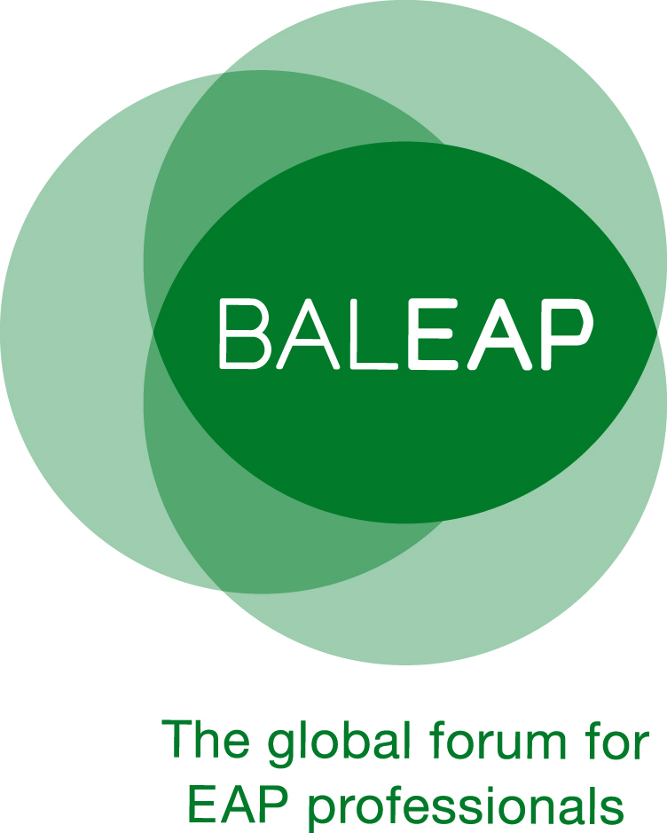 | English for Academic Purposes  2024* Master’s Dissertation Award  APPLICATION FORM
* The 2024 award covers dissertations for which grades were officially released between September 2023 and the cut-off point for award submissions (Friday 15th November 2024)

Applicant information
Family name
First name
Email address
Phone number
Correspondence address

Dissertation information
Dissertation title
Degree (to be) awarded | (Delete as appropriate: MA/MSc/MRes/MPhil.)
Awarding institution
Date of results release | (Indicate the date on the official document stating the mark for your dissertation.)
Result | (Indicate mark and/or classification and attach scanned copy of result.)
Dissertation abstract

Additional information to be provided by the applicant
In no more than 750 words, please explain:

- your methodological approach, data collection methods and sample, providing comprehensive information about the range and type of your data (this should include additional detail to the abstract)
- why you consider the work to be a key contribution to current knowledge in the EAP field,
- in what ways the BALEAP community can make use of insights from the dissertation (e.g., teaching, materials development, course design, staff development, quality assurance procedures, programme management, policy development, future research etc.).

Please note:
Completed application forms should be emailed to fundingandawards@baleap.org by Friday 15th November 2024.

Shortlisted candidates will be invited to submit an electronic copy of their dissertation in December 2024 and the winner will be notified in March 2025 and will be presented with their award at the BALEAP Conference in April 2025.

